Max Shi  
CH 362  
Professor Attygalle  
I pledge my honor that I have abided by the Stevens Honor System.

1) Title of Experiment:

Determination of Concentration of Sucrose in Unknown Solution, Diet Beverage, and Regular Beverage by Polarimetry

Date: October 30, 2020  
Name of Technique: Polarimetry

2) Technique:

Polarimetry is used to measure the concentration of chiral molecules, particularly sugars, peptides, and some volatile oils, inside solutions. Chiral molecules exhibit a phenomenon called optical activity, where a solution of a chiral molecule has a specific rotation when plane polarized light is passed through it. Chiral molecules rotate plane polarized light according to Equation 1:

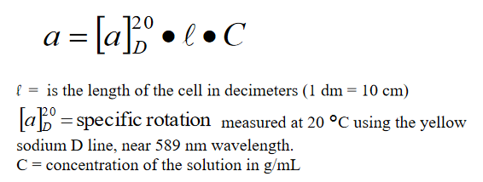

Equation 1: Rotation of Plane Polarized Light by Chiral Compounds

Because the angle of rotation is based on the concentration, calibration solutions can be used to create an ordinary linear calibration plot to calculate the unknown concentration, as long as the other variables in the equation are held constant. Due to the angle of rotation changing depending on the wavelength of the light used, as well as the path length of the cell, the sodium D line wavelength is generally used for all experiments, and the path length of the cell will be held constant.

The setup for the polarimeter begins with a lamp emitting light at the sodium D line, about 589 nm. The light then goes through a polarizer, which plane-polarizes the light. Then, the plane polarized light passes through a polarimetry cell, which is filled with the chiral sample solution. Then, the light passes through an analyzer, which is rotated until the angle of rotation is found, measured by the maximum light reading read by a detector at the end of the line. This process is detailed in more detail in Figure 1.

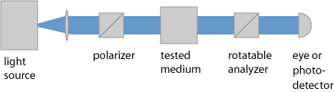

Figure 1: Diagram of Polarimeter

3) Application of the Technique to my Experiment

Sucrose, depicted in Figure 2, is chiral and is optically active in solution, and therefore, the concentration of sucrose in solution can be measured by polarimetry. First, five calibration solutions will be prepared from a stock solution prepared from sucrose and deionized water. Then, the path length of the cell will be noted, and the machine will be first zeroed by taking a measurement with the cell filled with only deionized water. Then, the five solutions’ optical activity will be measured with the polarimeter, and a calibration plot will be constructed from the concentration and angle of rotation measured of each solution.

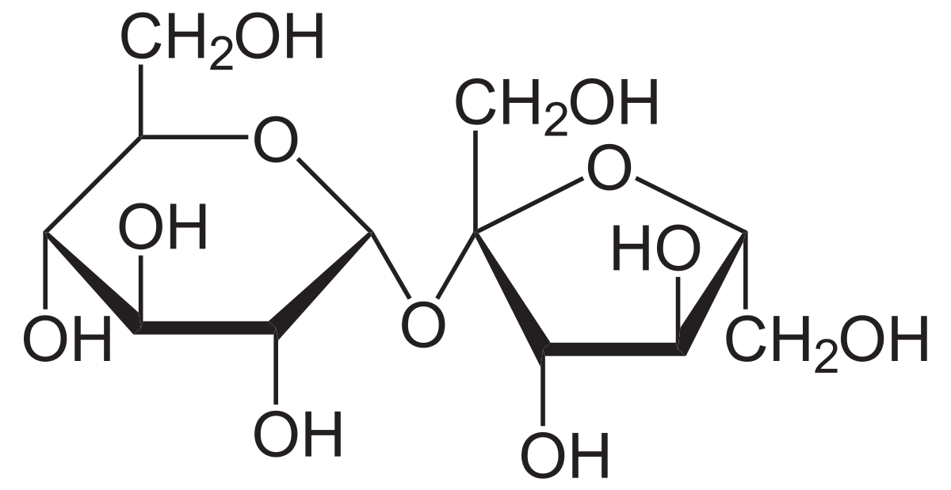

Figure 2: Structure of Sucrose

After the calibration plot has been created, each of the unknown solutions, the sugar solution, the diet beverage, and the regular beverage, will be put into the polarimetry cell and their angle of rotation will be taken, one at a time. By plotting the angle of rotation on the calibration curve, the concentration of sucrose in each of the solutions can be calculated.

4) Calculations

As concentration in Equation 1 is measured in g/mL, it is important to prepare solution in terms of w/v.

To produce a 10.0% w/v solution, 25 g of sucrose must be dissolved into deionized water to create a 250.0 mL solution.

**Preparation of calibration solutions from 250.0 mL 10.0% w/v solution**

Each mL of stock solution contains 0.1 g of sucrose.  
To prepare 50.0 mL solutions of x% w/v solution from stock solution, each solution requires 5*x mL of stock solution, diluted to 50.0 mL.

|  |  |  |
| --- | --- | --- |
| Desired Concentration (w/v) | Amount of stock solution (mL) | Amount of deionized water (mL) |
| 1.0 | 5.0 | 45.0 |
| 2.0 | 10.0 | 40.0 |
| 4.0 | 20.0 | 30.0 |
| 6.0 | 30.0 | 20.0 |
| 8.0 | 40.0 | 10.0 |

5) References:

1. 1920px-Saccharose2.svg.png (PNG Image, 1920 x 991 pixels) <https://upload.wikimedia.org/wikipedia/commons/thumb/1/1a/Saccharose2.svg/1920px-Saccharose2.svg.png> (accessed Oct 31, 2020).
2. Attygalle, A. Instrumental Analysis I Lecture and Laboratory Manual <https://sit.instructure.com/courses/38802/files/6982711?module_item_id=1042514> (accessed Oct 31, 2020).
3. polarimeter.png (PNG Image, 435 x 120 pixels) <https://www.rp-photonics.com/img/polarimeter.png> (accessed Oct 31, 2020).

6) MSDS:

**Sucrose**

CAS No.: 57-50-1  
Molecular Weight: 342.1474  
Chemical Formula: C12H22O11  
Appearance: white solid   
Lab Protective Equipment: Lab coat, goggles

**Health effects:**May cause skin and eye irritation, may cause respiratory and digestive tract irritation.

**First Aid measures:**Eye contact: rinse immediately with water, especially under eyelids, for >15 minutes. Get medical attention.  
Skin contact: Obtain medical attention if irritation develops or persists.  
Inhalation: Move to fresh air. If breathing if difficult, give oxygen. If not breathing, give artificial respiration. Get medical attention immediately if symptoms occur.  
Ingestion: Do not induce vomiting. If victim is conscious and alert, give 2-4 cupfuls of milk or water. Get medical attention if irritation or symptoms occur.

**Other hazards:**Fire: not known to be a fire hazard.  
Explosion: not known to be an explosion hazard.

7) Pre-lab questions:

1. Anomers are cyclic sugars which differ from each other in the configuration of one carbon in the cyclic ring, where one anomer will have a functional group on one side of the ring, and the other anomer will have the functional group on the other side of the ring. This differs from enantiomers because anomers form when simple sugars convert to their cyclic forms and is not represented in the open form (Fischer Projection) of the sugar. Thus, D-glucose, for example, can form a pair of anomers when converted to cyclic form, outside of its four chiral carbons represented in the Fischer projection that determine its identity as D-glucose.

$$a={\left[a\right]}_{D}^{20}*l*C \\ C=\frac{70.00 mg}{10.00 mL}*\frac{1 g}{1000 mg}=0.007\frac{g}{mL} \\ l=2.0 cm=0.2 dm \\ a=0.087° \\ 0.087={\left[a\right]}_{D}^{20}*0.2*0.007 \\ {\left[a\right]}_{D}^{20}=62.14\frac{°*mL}{dm*g}$$